Maximum Iterations: set the maximum number of iteration of the ICP algorithm

Transformation Epsilon : Set the transformation epsilon so the maximum allowable difference between two consecutive transformations

Euclidean Fitness Epsilon: Set the maximum allowed Euclidean error between two consecutive steps in the ICP loop, before the algorithm is considered to have converged

Max Correspondence Distance : set the maximum distance threshold between two correspondent points in source <-> target. If the distance is larger than this threshold, the points will be ignored in the alignment process
Brute ICP : The Brute ICP algorithm aims to find the transformation between a point cloud and another point cloud, by minimizing the square errors between the corresponding entities.

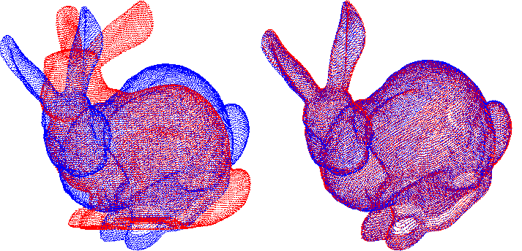
Normal ICP:
Given a source surface and a destination surface, each iteration of the ICP algorithm first establishes a set of pair-correspondences between points in the source surface and points in the destination surfaces. For example, for each point on the source surface, the nearest point on the destination surface is chosen as its correspondence [Besl92] (see [Rusinkiewicz01] for other approaches to find point correspondences). The output of an ICP iteration is a 3D rigid-body transformation M that transforms the source points such that the total error between the corresponding points, under a certain chosen error metric, is minimal. When the point-to-plane error metric is used, the object of minimization is the sum of the squared distance between each source point and the tangent plane at its corresponding destination point 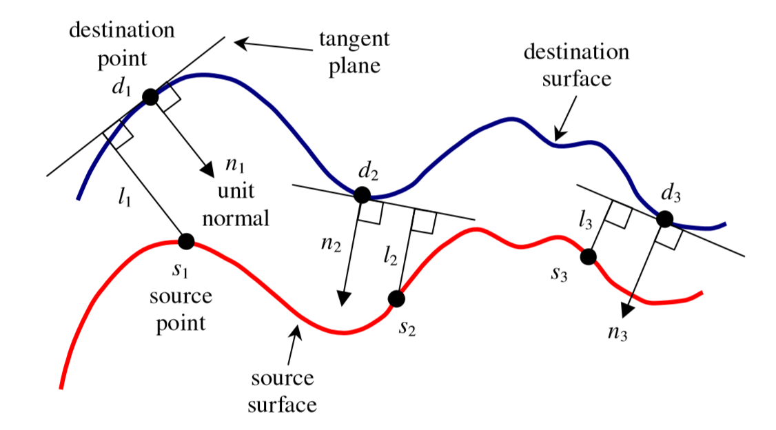
Normals: https://youtu.be/x1FSssJrfik
Video comparison between point-to-point and point-to-plane
https://www.youtube.com/watch?v=LcghboLgTiA

The ”iterative” of ICP comes from the fact that the correspondences are reconsidered as the solution comes closer to the error local minimum

